Week-10
Create a database instance in the cloud using Amazon RDS and Google Cloud SQL.

Google Cloud SQL.

Step 1: Open Google Cloud Console
- Open the Google Cloud Console.
- Sign in using your Google account.
- At the top of the page, click the Project Selector.
Step 2: Create a New Project
- Click New Project.
- Enter the project name:
Cloud-Database-Lab
- Click Create.
- Select the newly created project.
Step 3: Open Cloud SQL
- Click the ☰ Navigation Menu.
- Select Cloud SQL.
- Click Create Instance.
Step 4: Select Database Type
You will see options such as:
- MySQL
- PostgreSQL
- SQL Server
Select MySQL.
Step 5: Configure the Instance
Enter the following details:
Setting | Example
Instance ID | my-cloud-db
Password | Create a strong password
Database version | Select the available MySQL version
Region | asia-south1 (Mumbai)
Keep the other settings at their default values for a basic practical.
Step 6: Select Machine Configuration
Choose a small machine configuration suitable for your lab.
For a basic demonstration, avoid selecting unnecessarily large CPU or memory resources.
Step 7: Configure Connections
Under Connections, configure the connection method required for your practical.
If you need to connect from your computer, enable Public IP and configure the appropriate authorized network.
Step 8: Create the Instance
Check the configuration and click:
Create Instance
Google Cloud will now create your Cloud SQL instance.
Wait until the instance becomes Running/Ready.
Step 9: Create a Database
After the instance is created:
- Open your Cloud SQL instance.
- Select the Databases tab.
- Click Create Database.
- Enter: college_db
- Click Create.

Step 10: Verify the Database
You can now see:
Cloud SQL Instance
│
└── MySQL
│
└── college_db
Your Google Cloud SQL database instance has been successfully created.

Create a Database Instance in the Cloud Using Amazon RDS
Step 1: Open AWS Management Console
- Open the AWS Management Console.
- Sign in with your AWS account.
- In the search bar at the top, type RDS.
- Select Amazon RDS.
Step 2: Open RDS Dashboard
After opening Amazon RDS:
- You will see the RDS Dashboard.
- In the left-side menu, select Databases.
- Click Create database.
Step 3: Select Database Creation Method
You will see two options:
- Standard create
- Easy create
Select:
Standard create
This allows you to configure the database settings manually.
Step 4: Select Database Engine
Under Engine options, select:
MySQL
Then select an available MySQL version.
Example:
Engine: MySQL
Step 5: Select a Template
Under Templates, select:
Free tier

Step 6: Enter Database Identification
Under Settings, enter the following:
Setting | Example
DB instance identifier | mydatabase
Master username | admin
Master password | Create your password
Confirm password | Enter the same password

Example
DB Instance Identifier: mydatabase
Master Username: admin
Master Password: ********
Step 7: Configure Instance
Under Instance configuration, select an eligible small/free-tier configuration.
For a basic practical:
DB instance class → Small/free-tier eligible option
Step 8: Configure Storage
Under Storage, configure:
Storage type: General Purpose SSD
Allocated storage: Minimum suitable value
Step 9: Configure Connectivity
Scroll to the Connectivity section.
Select:
Virtual Private Cloud (VPC): Default VPC
Public access: Yes
VPC security group: Create new
Give the security group a name such as:
rds-security-group
Important
For a classroom demonstration, Public access = Yes may be convenient when connecting from your computer.
For production applications, databases are normally configured with tighter network access, often using private connectivity.
Step 10: Additional Configuration
Under Additional configuration, you can specify:
Initial database name
college_db
This automatically creates a database named college_db inside the RDS instance.
You can leave other settings at their default values for the practical.
Step 11: Review the Configuration
Before creating the database, check:
Engine → MySQL
DB Identifier → mydatabase
Username → admin
Database Name → college_db
Instance Class → Small/free-tier eligible
Storage → General Purpose SSD
VPC → Default VPC
Step 12: Create the Database
Click:
Create database
AWS will start creating your RDS instance.
You will see:
mydatabase
↓
Creating
↓
Available
Wait until the status changes to Available.
Step 13: Get the Database Endpoint
After the database becomes available:
- Click your database instance mydatabase.
- Open the Connectivity & security section.
- Find Endpoint.
It will look similar to:
mydatabase.xxxxxxxxxxxx.ap-south-1.rds.amazonaws.com
This endpoint is used to connect to your MySQL database.
Step 14: Verify the Database
Your final setup will look like:
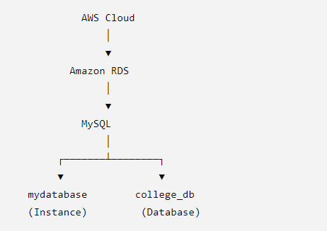
Simple Steps to Remember
AWS → RDS → Create Database → MySQL → Free Tier → Settings → Storage → Connectivity → Create → Available → Endpoint
Practical Result
A MySQL database instance named mydatabase is successfully created in Amazon RDS, with a database named college_db.

Week-11
Create and configure virtual machines using VM Ware’s Workstation.
Step-01
Download the vmware-workstation
https://www.techspot.com/downloads/189-vmware-workstation-for-windows.html
Install it.
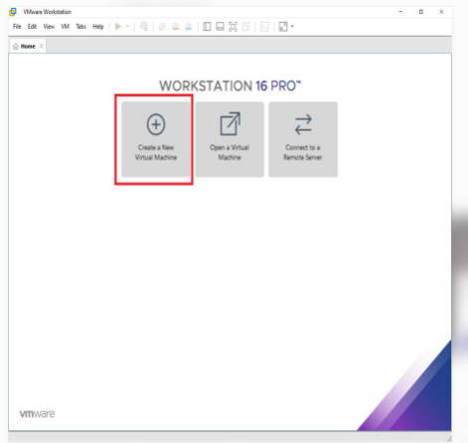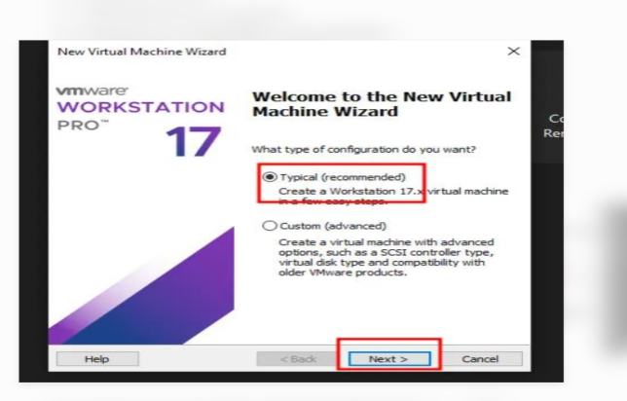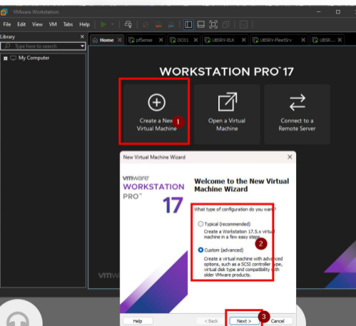

Step 2: Create a New Virtual Machine
- Click Create a New Virtual Machine.
- Select Typical (Recommended).
- Click Next.
Step 3: Select the ISO File
1. Select Installer disc image file (ISO).
2. Click Browse.
3. Select your Ubuntu ISO file. https://ubuntu.com/download/desktop

Step 5: Give the VM a Name
Enter:
Ubuntu-VM
Choose a location where you want to save the virtual machine.
Example:
D:\Virtual Machines\Ubuntu-VM
Click Next.

Step 6: Set Hard Disk Size
Enter:
30 GB
Select:
Store virtual disk as a single file
Click Next.

Step 7: Configure Hardware
Click:
Customize Hardware
Set:

Memory
4 GB

Processor
2 CPU cores

Step 8: Start the Virtual Machine
- Select your VM:
Ubuntu-VM
- Click:
Power on this virtual machine
Ubuntu will start.

Step 10: Restart the VM
After installation:
- Click Restart Now.
- Ubuntu will restart.
- Log in using the username and password you created.
Now your virtual machine is ready.

Step 11: Test the Virtual Machine
Open Terminal inside Ubuntu.
Run:
pwd
You should get something similar to:
/home/student
Check the operating system:
lsb_release -a
Check the IP address:
ip addr
Test Internet:
ping google.com
If you receive responses such as:
64 bytes from google.com
the network is working.
Stop the ping using:
Ctrl + C

Step 12: Install VMware Tools
In Ubuntu Terminal, execute:
sudo apt update
Then:
sudo apt install open-vm-tools open-vm-tools-desktop -y
Restart:
sudo reboot
Open VMware
↓
Create New VM
↓
Select Ubuntu ISO
↓
Select Linux → Ubuntu 64-bit
↓
Set RAM = 4 GB
↓
Set CPU = 2 cores
↓
Set Disk = 30 GB
↓
Network = NAT
↓
Finish
↓
Power ON
↓
Install Ubuntu
↓
Test Network
↓
Install VMware Tools

Week-12
Implementation of Para-Virtualization using VM Ware’s Workstation/Oracle’s Virtual
Box and Guest O.S.

Step 1: Install VMware Workstation
- Download and install VMware Workstation.
- Open VMware Workstation.
- Make sure hardware virtualization is enabled in BIOS/UEFI.

Step 2: Download Ubuntu ISO
Download the Ubuntu ISO file.
The file will normally look similar to:
ubuntu-24.04.x-desktop-amd64.iso
Save it somewhere easy to find, such as:
Downloads

Step 3: Create a New Virtual Machine
Open VMware Workstation.
Select:
Create a New Virtual Machine
Choose:
Typical (Recommended)
Click Next.

Step 4: Select Ubuntu ISO
Select:
Installer disc image file (ISO)
Click Browse and select your downloaded Ubuntu ISO.
Example:
Downloads → ubuntu-24.04.x-desktop-amd64.iso
Click Next.

Step 5: Configure the Guest OS
Enter the required information:
Full Name: Student
Username: student
Password: ********
Click Next.

Step 6: Give a Name to Virtual Machine
Example:
Virtual Machine Name:
Ubuntu-ParaVirtualization
Select a location where you want to store the VM.
Example:
D:\Virtual Machines\Ubuntu
Click Next.

6. Allocate Virtual Hardware
Recommended settings for a student experiment:

Memory
RAM = 4 GB

Processor
Processors = 2

Hard Disk
Disk Size = 30 GB
You can increase these values if your computer has sufficient resources.

7. Start the Virtual Machine
Click:
Finish
Then click:
Power on this virtual machine
Ubuntu installation will start.
Follow the Ubuntu installation instructions.
After installation, restart the VM.

8. Install VMware Tools
This is an important step for demonstrating the enhanced interaction between the Guest OS and the virtualization platform.
Inside Ubuntu, install VMware Tools/open-vm-tools:
sudo apt update
Then:
sudo apt install open-vm-tools open-vm-tools-desktop
Press:
Y
when asked for confirmation.
Restart Ubuntu:
sudo reboot

9. Verify the Virtual Machine
After Ubuntu starts, verify that it is working correctly.
Open the Ubuntu Terminal and execute:
uname -a
You should see information about the Ubuntu kernel.
Check memory:
free -h
Check CPU:
lscpu
Check disk:
df -h

10. Demonstration of Para-Virtualization
The main idea is to show that the Guest OS can use virtualization-aware drivers/interfaces provided by the virtualization platform.
For example, VMware provides virtual devices and optimized drivers that allow the Guest OS to interact efficiently with the hypervisor.
You can explain:
Guest OS
↓
Para-virtualized / optimized drivers
↓
Hypervisor
↓
Physical Hardware
For VMware, tools such as open-vm-tools provide improved integration between Ubuntu and VMware.

11. Procedure Using Oracle VirtualBox
If your laboratory uses Oracle VirtualBox instead of VMware, the procedure is similar.

Step 1
Install Oracle VirtualBox.

Step 2
Open VirtualBox.
Click:
New

Step 3
Enter:
Name: Ubuntu-ParaVirtualization
Type: Linux
Version: Ubuntu (64-bit)

Step 4
Select the Ubuntu ISO file.

Step 5
Allocate:
RAM: 4 GB
CPU: 2 cores
Hard Disk: 30 GB

Step 6
Click:
Start

Step 7
Install Ubuntu as the Guest OS.

Step 8
After installation, install VirtualBox Guest Additions for better integration and optimized virtual device support.
In Ubuntu, you can install the relevant packages

